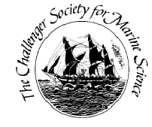
Challenger Society for Marine Science
Student Travel Award Report Form
Please complete this form as a Word Document ONLY and return it to Dr Sophie-Berenice Wilmes (s.wilmes@bangor.ac.uk).

Title of report/travel/event attended:

Awardee Name:

Institution:

Report: (750 words max)

Awardee Profile: (100 words max)

Year of travel/event:

Please attach ONE photo or image upon email submission of this form.

